**Supplementary Materials**

Table of Contents

1. Simple Parameter Estimation with SIR: 2

Introduction: 2

Application on AUSSIE dataset: 2

References 4

**Figure 1: Estimations of m and $γ$ (from notebook – ADD LINK HERE)** 3

Figure 2 Compare number of infected 3

1. Simple Parameter Estimation with SIR: $\left\{\begin{aligned}\frac{dS}{dt}= - \frac{β}{N}SI (i) \\ \frac{dI}{dt}= \frac{β}{N}SI- γI (ii) \\ \frac{dR}{dt}= γI (iii)\end{aligned}\right.$ [1]

## Introduction:

* Some information should be noted:
  + N = I + S + R
  + Goal: Estimate beta, gamma (infection rate and recovery rate, respectively)
  + As I have introduced here (add link later), the Bayesian Inference helps us to determine the proportion of population who are highly immune to the current pandemic, hence, Exposed Population $≈$ Susceptible Population $≈$ N (population excluded those who are immune). At the first day of pandemic (N=S):

**∴ I(t) ~ I0** (since I grows exponentially)

#*with t is time interval and I0 is the number of infection in day* 1

**∴ ln(I) = mt + ln(I0) [2]**

# From equation [2], we can easily estimate the value of m using log plot and the dataset from official source then using least square method to fit the line.

**Note:** Different time intervals might produce different results of m, the higher m means the more uncontrolled pandemic was at the time t interval.

* + Then we can estimate the value of recovery rate $γ$ by using 2 ways: using the number of days in infection period certified by health authorities or we can using [1.iii] equation to reckon the rate $γ.$
    - R(t) = $γtI_{0}$
    - $γ ≈ \frac{R\left(t+1\right)-R(t)}{I(t)}$*#I got a little concern in this part, if we account for the incubation period, it should be: $γ ≈ \frac{R\left(t\right)-R(t-ϵ)}{I(t)}$ with $ϵ$ is the length of incubation period. Let’s just stick with R(t+1) first since it is technically complicated to compute a certain value for incubation period*

$After having values of γ and m, it is now easier to find the value for β$

## Application on AUSSIE dataset:

* The scope of this research is the first 60 days of pandemic (because it is the initial stage of pandemic where number of infected = $\sqrt{total infected}$ as defined by (Diekmann, 2011)

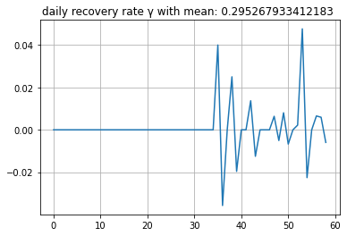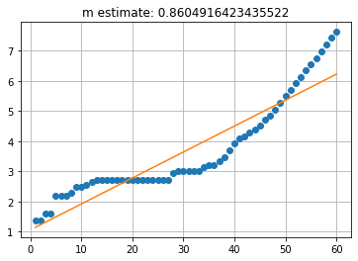

**Figure 1: Estimations of m and $γ$ (from notebook – ADD LINK HERE)**

Figure 1 displays that the value of m and gamma is 0.8 and 0.29 respectively. We have final table of parameter estimation for the first method

|  |  |  |
| --- | --- | --- |
| β=0.565224 | γ=0.295268 | R0 = β/ γ = 1.91427 |

* We have a model comparison:

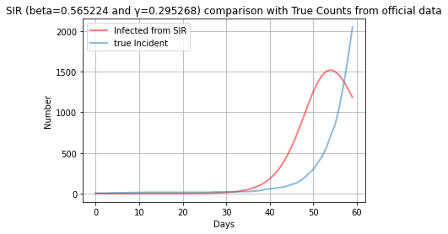

**Figure 2 Compare number of infected**

##### Evaluation for later remark

# References

Allcroft, D. (2003). A simulation-based method for model evaluation. *Statistical Modelling*, 1-13.

Chin, C. (2005). *Application of Poisson Underreporting Model to Examine Crash Frequencies at Signalized Three-Legged Intersections.*

Diekmann, O. (2011). *Mathematical Tools for Understanding Infectious Disease Dynamics .* Princeton Publication.

Gerald, N. (2009). Size Estimation - Statistical Models for underreporting. *JOAHNEUM RESEARCH* .

Lelieveld, J. (2020). Model Calculations of Aerosol Transmission and Model Calculations of Aerosol Transmission and. *International Journal of Environment and Public Health* .

Manfredi, P. (2017). *Modeling the interplay between human behaviour and the spread of infectious diseases.* Springer.

Neubauer, G. (2011). Models for Underreporting: A Bernoulli Sampling Approach for Reported Counts. *Austrian Journal of Statistics*, 85-92.

Shapiro, M. (2011). FINDING THE PROBABILITY OF INFECTION IN AN SIR NETWORK IS NP-HARD. *Science Direct*.

Tennekoon, V. (2017). Counting Unreported Abortion: A Binomial-thinned zero-inflated Poisson Model. *Demographic Research*, 41-72.

Wood, J. (2015). A method to account for and estimate underreporting in crash. *Accident Analysis and Preventation*, 57-65.

Zhao, Y. (2010). Modeling the Underreporting Bias in Panel Survey Data. *Marketing Science*, 525-539.